Intelligent Maps and Information Landscapes
Two new Approaches to support Search and Retrieval of Environmental Information Objects
Klaus Tochtermann, Vedran Sabol, Wolfgang Kienreich, Michael Granitzer and Jutta Becker
Abstract
In this paper, we present how two different knowledge retrieval techniques can be applied to improve search and retrieval for environmental information objects. Both approaches have in common that they provide users with as much guidance as possible. Our first approach capitalises on geographical metadata and intelligent maps as retrieval tool. The idea is to start a query with an intelligent map and to systematically narrow the scope of interest by choosing different query parameters. With our second approach we generate information landscapes, i.e. two-dimensional maps to display the results of search queries. In information landscapes documents with similar content are placed closer together, and islands appear where there is a concentration of closely related documents. The paper closes with a comparison of the two approaches and suggestion about when to use which approach.

Introduction
The characteristics of environmental information make it a challenging commodity for environmental information systems to manage. Environmental information is typically made up of a variety of different data types. Examples include satellite photos, cartographic information, the results of empirical observations, environmental studies and reports etc. In addition to their density of type, environmental information is often quite large in size. In order to provide effective access to this type of information, the majority of environmental information systems provides some sort of metadata, i.e. data describing data (Tochtermann 2002). The metadata mainly serves the purpose to easily find environmental information objects in systems such as GEIN (www.gein.de) or UDK (www.umweltdatenkatalog.de) and to improve the quality of search results. A drawback such systems have in common with standard search engines is that they display the results of a query as overwhelmingly long list of hits pointing to the respective environmental information object. The main disadvantage is that users do not get in one step what they are looking for after they have submitted a query. Instead, in a second step, they have to continue their search but now in the set of query results. And for the second step neither environmental information and metadata systems nor standard search engines provide much support.
Based on this observation the idea is to capitalize on identified synergies between knowledge management and environmental informatics (Tochtermann et al. 2000). With this in background, this paper presents two different knowledge-based approaches for searching and retrieval of environmental information objects. The idea for both approaches is to provide enhanced user guidance based on existing metadata. The first approach, described in Section 2, uses intelligent maps which allow conceptual navigation through repositories of environmental information objects. Section 3 presents the second approach which generates information landscapes based on existing metadata and other additional information. Section 4 compares the two approaches before our paper closes in Section 5 with a short summary and outlook on future work.

Intelligent maps
In environmental informatics each environmental object (e.g., a lake, a forest etc.) has a geo-reference describing its geographical location (Tochtermann 2002). This is why geographical metadata play a crucial role in environmental information systems. Geographical metadata refers to a physical region using geographical names or coordinates. To define geographical metadata for a query, environmental information systems commonly provide textual query interfaces, that is users have to type in the name of a region (e.g., “Vienna”) to define the geographical relationship of the resources to be searched for. Similar to this, the results of a query are displayed as a textual list of links pointing to the environmental information objects matching the query. In special cases (e.g., Z39.50 compliant query languages) it is required that not only sophisticated but also casual users have to be familiar with the syntax of the query language and with the geographical names the system “understands”. To support users, sometimes geo-thesauri are integrated in a system (ADL 2002) allowing users to retrieve environmental information objects by selecting geographical names or geometries provided by the geo-thesaurus
The drawback of the known approaches is that multi-referenced queries (i.e., queries in which many different relationships such as thematic, temporal and geographical relationships are applied) are not supported. As a result, this requires different query interfaces, one for thematic and temporal and one for geographical queries.
Based on this observation, we developed the idea of supporting environmental information systems with intelligent maps. In our notion, we refer to a map as intelligent map if the following requirements are fulfilled:
- the map “knows” how many environmental information objects exist for each geo-object of the map,
- the map supports multi-referenced queries in one interface,
- all queries formulated with using the map yield at least one hit (i.e. empty result sets are not possible),
- the map does not only support the query formulation but also the display of the query results,
- result sets are displayed on the map according to their geo-reference.

The intelligent map of the PADDLE system
PADDLE is a personal adaptable digital library environment which offers its users an intelligent map to support search and retrieval of environmental information objects (Tochtermann 2002b). The underlying repository of environmental information objects consists of 100.000 environmental legislations and 3000 documents describing the state of the environment in Germany in 1997. This section describes how users interact with this map and why this maps fulfils the requirements for intelligent maps.
The different colors of the geo-objects in the map shown in figure 1 indicate the number of environmental information objects which exist for this geo-object (i.e. which have a geo-reference correlating with the geo-object). This gives users a first indication about the possible number of results for a query. Thus, requirement (1) for intelligent maps is fulfilled.
To formulate queries, a technique referred to as geographical access is applied (Kraak et al. 1997). This means that in a first step users specify the geographical relationship of their query by clicking on a point or on a geo-object by defining a rectangular geometry etc. After users have selected a geo-object, they get access to a subject tree containing all thematic relationships of information resources which are indexed with the respective geo-reference. As a result, the system displays only those thematic relationships to which information objects exist which are geo-referenced with the geo-object selected in step 1. Users choose one or more entries in the subject tree to define the thematic relationship for their query. The same approach can be applied for other relationships such as time. With this “intelligence” the system guides users through the jungle of possible queries. At the end, users have formulated queries which always yield a non-empty list of hits. With this functionality, requirements (2) and (3) for intelligent maps is fulfilled.

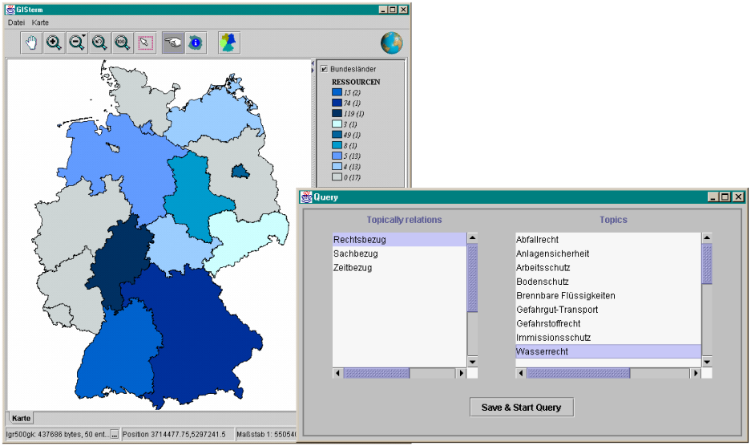
- Users select a geo-object
- A window appears to select further relationships for the query
The colour of the geo-objects indicate how many information objects exist:
- 4 existing environmental information objects
- 119 existing environmental information objects

Fig. 1: Formulation of a query Search for all environmental information objects which are geographically related to the ”State of Hessen” and which deal with ”Wasserrecht”.
The results of such a query are not displayed as a textual list of links pointing to the environmental information objects. Instead, we use the concept of footprints. Presenting footprints on maps is a well-known concept (Larson 1995). The idea is to provide footprints as hypermedia links on a map. The selection of a footprint brings up all information objects referenced by the link. We also use footprints in another sense, in that we visualize stored queries as footprints on maps. Whenever users select a footprint, the query can be revised before it will be sent to the system which returns the corresponding information objects (c.f. fig. 2).
With the concept of footprints our approach fulfils requirements (4) and (5) of intelligent maps.
A detailed description of the underlying concepts, the software architecture and the implementation can be found in (Tochtermann 2002b).

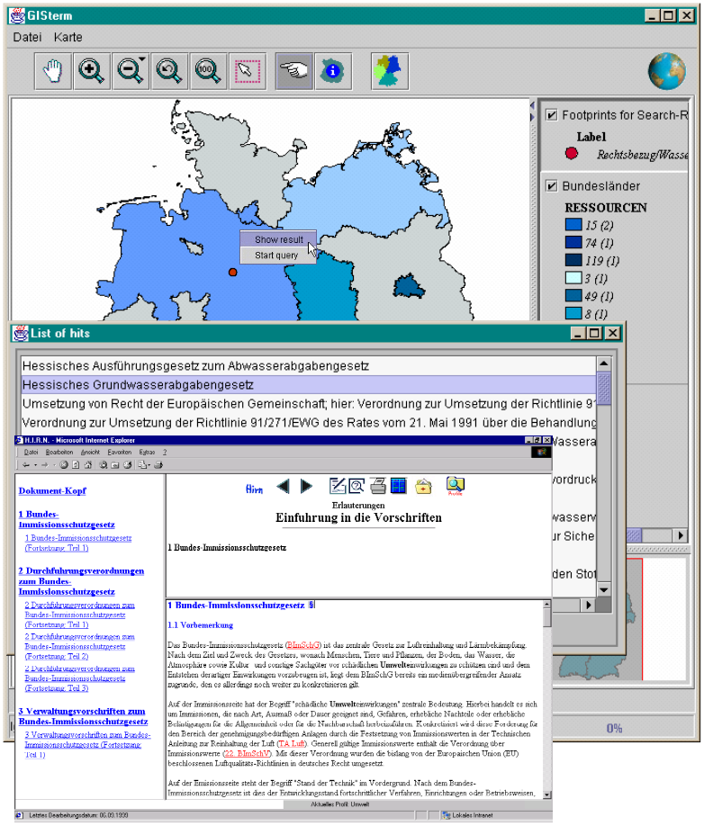
- Users select a footprint
- A list with results for this footprints appears where users select a link
- Environmental information object appears
Fig. 2: Using footprints to access environmental information objects

Information Landscapes
This section presents our second and completely different approach of applying knowledge retrieval and visualization techniques for searching and retrieving of environmental information objects.
Standard search engines expose the content of millions environmental information objects through query interfaces which usually take a lists of two to four keywords and return a one-dimensional result list sorted by relevance. Result lists typically contain thousands of items, as the number of keywords commonly provided is much too small to narrow results down to a manageable amount. Ambiguities between keywords and abbreviations characteristic for the environmental context only worsen this situation. Two observations summarize the problem and point towards a possible solution:
Some query keywords are better than others: Specific to search space and used engine, some query keywords lead to a much better narrowing of the result set than others. Providing users with a selection of such “power keywords” eases search result refinement and leads to a better understanding of what a given result set is all about.
Relevance cannot be measured in one dimension. Result sets typically cluster around several topics. A (one-dimensional) relevance-sorted result list insufficiently represents this structure. Providing users with distinct clusters of documents dealing with the same topic would allow users to comprehend the result space of a query and to easily refine their initial search.
We suggest to apply visualization islands to overcome these shortcomings of standard search engines. Visualization Islands (Sabol 2001) is a visualization system based on the principle of information landscapes (Chalmers 1993). They visualize query results as a satellite view of an island landscape. Each result item is represented by a small island, with similar items being placed close to each other. Resulting clusters of islands can be identified and labeled using data from the underlying information objects.

Visualising the UDK result sets with the WebRat system
WebRat is a multipurpose retrieval and visualization framework utilizing the information island. (Granitzer et al., 2002). WebRat allows users to formulate queries against any number of configured data sources (i.e. indexing services, web search engines, intranets etc.). Query results are then merged, clustered and visualised with labels describing the most obvious clusters of found documents to allow easy query reformulation and refinement. For use in an environmental context, WebRat has been connected to GEIN and UDK.
Returned results are processed by the system and displayed in a visualisation. Results form islands on a virtual satellite map which are labelled with the according keywords. As figure 3 shows, the concept of the visualization is simple: documents with similar content are placed closer together, and islands appear where there is a concentration of closely related documents. The areas between islands can be interesting because they contain fewer documents but with maybe more unique content.
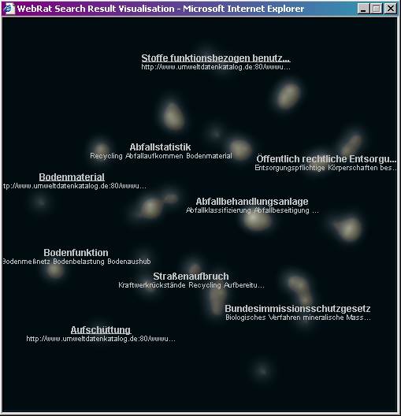
Fig. 3: WebRat displaying results for a query for “Abfallverwertung” in UDK,
9 thematic islands (e.g., Bodenfunktion, Abfallstatistik) are identified by WebRat
The visualisation is updated in regular intervals as more and more results arrive. Users can zoom in and out on the map, revealing more details or displaying an overview in the process. Labels are calculated on the fly, accordingly, to always describe the most obvious concentrations of documents (the biggest islands).
For each labelled island, users can call up a context menu using the right mouse button, which allows to explore any of the used repositories by refining the original query with the label keywords of the selected island. This way, users can refine query terms quick and efficient. In addition, the context menu contains basic navigational functionality like zoom in, zoom out and “home”, which resets the point of view to display the whole map.
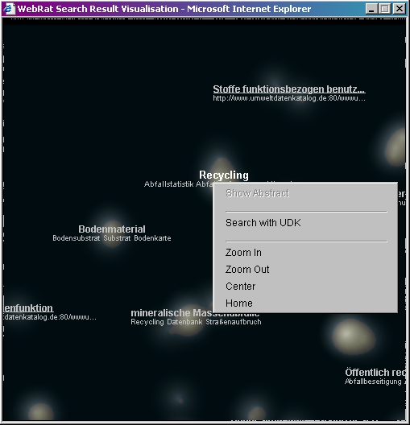
Fig. 4: Zoom of Fig. 3 and refined a query result with WebRat

Comparison of the two approaches
The metadata-based approach of the intelligent maps is preferable whenever users have a clear idea of what they are looking for. In this case, the intelligent maps support users in conceptual navigation through heterogeneous repositories of environmental information objects. Conceptual navigation allows users to systematically narrow their scope of interest by forming strategic sequences of why? (purpose), how? (means), when? (temporal boundaries), where? (geographical boundaries), what? (subject) and who? (person) (Veltman 1997). Supporting this concept, intelligent maps can directly guide users to what they are interested in. While navigating through the repositories the system continuously communicates with the underlying repository to avoid that a strategic sequence ends up in an empty result list – this is probably the main advantage compared to standard search engines. Another advantage is the intuitive user interface. Users greatly benefit from non-textual input methods tailored to the area of interest (i.e. footprints for geographical information systems). Instead of typing in geographical names or even coordinates, users can simply use geo-objects to define the geo-reference for their query. However, since this approach heavily relies on metadata, the quality of the results of such a strategic sequence of queries depends on the quality of the metadata. Another disadvantage is the complex system environment with a Web-GIS system and a Web-GIS client which is needed to implement this approach (Tochtermann 2000b).
In contrast to intelligent maps, the information landscapes do not support conceptual navigation but “traditional” browsing. That is users have only a vague idea of what they are looking for and want to get an overview over a topic based on comparable few keywords entered in a textual form. As a result of a query, typical search engines overwhelm users with a often endless list of hits. The main disadvantage is the lack of context as the hits are just listed in a linear sequence. Exploiting information which exists anyway is the key idea of our approach. As described in the previous chapter our tool analyses existing data (e.g., metadata, abstract, related terms etc.) to build thematic clusters of the hits and, thus, provide context to the users. The context is an added-value particularly for those users who are novices in a thematic field and who need guidance to get to know this field. Starting with a first overview at the highest level, users can either zoom into a more detailed level or they can refine their query.
Similar to intelligent maps the quality of the results depends on the quality of the abstracts, the metadata and the related terms. The system requirements for the WebRat are much lower than those for the intelligent map since only a Java Applet has to be loaded in a standard browser. However, locating a clearly specified environmental information object is not the strength of WebRat: Standard search engines are superior in this case because they allow for faster and more accurate identification of single items. In addition, WebRat works with whatever metadata and content snippets a search engine returns: This can lead to low quality results if few metadata or poor snippets are available, and there may even be no results at all if all repositories return empty result sets. Still, as environmental metadata is usually of high quality, particularly in the case of UDK, WebRat turns out to be an appropriate, easy to use tool for search and retrieval of environmental information objects.

Summary and Outlook
This paper presented two novel approaches to explore complex environmental repositories. The underlying idea of both approaches is to provide users with as many guidance as possible without constraining users too much. Intelligent maps used in PADDLE are suited especially well for a geographic context where well-defined environmental information objects are described by lots of metadata and where users are looking for specific documents. WebRat works best in a multi-repository environment providing less meta-data but actual information object content, with users wanting to get overviews on topics and to narrow result sets effectively. The two approaches can coexist well and would profit from each other if one would exchange some of their features and ideas.
In the future, the intelligent maps will be extended in two ways. Firstly, a new feature will be integrated which allows users to get informed about changes of environmental information objects stored in the repository. Secondly, we will be integrating recommender algorithms to recommend users environmental information objects according to their profile of interest. The WebRat will be extended by adding further repositories, the query results of which can be merged to extend the number of relevant documents found. Metadata will be integrated more tightly by weighting known metadata fields in comparison to general information as provided in content snippets. Finally, the clusters identified by the system can be arranged into a hierarchy representing a whole document space (not just a search space).
Bibliography
ADL (2000): Alexandria Digital Library. http://www.alexandria.ucsb.edu/
Chalmers M. (1993). Using a landscape metaphor to represent a corpus of documents. COSIT 93, pages 337-390, September 1993.
Dodge, M. (2002): An Atlas of Cyberspaces, http://www.cybergeography.org/atlas/atlas.html
Granitzer M., Kienreich, W., Sabol, V (2002): WebRat - a retrieval, clustering and visualisation framework for interactive refinement of web-based queries, June 2002. Know-Center Technical report, paper submitted.
Kraak, M.-J., Driel, R. (1997). Principles of Hypermaps, Computers and Geosciences, Vol. 24, No 4, 1997, pp. 457-464, http://www.itc.nl/~kraak/hypermap/Hypermaps.html
Larson, R. (1995). Geographic Information Retrieval and Spatial Browsing. School of Library and Information Studies, University of California, Berkeley. http://sherlock.berkeley.edu/geo_ir/PART1.html.
Sabol, V. (2001). Visualisation Islands: Interactive Visualisation and Clustering of Search Result Sets, Master’s Thesis at IICM, Graz University of Technology.
Tochtermann, K., Maurer, H. (2000): Knowledge Management and Environmental Informatics. Journal of Universal Computer Science, 6(4), Springer Publisher & Co., May 2000, p. 517-536, http://www.jucs.org.
Tochtermann, K. (2002a): Environmental Informatics; Encyclopedia of Environmetrics, (eds. A. El-Shaarawi, W. Piegorsch), Bd. 2, S. 1047-1053, John Wiley & Sons, 2002.
Tochtermann, K. (2002b): Personalization in the context of digital libraries and knowledge management, Habilitation Thesis at TU Graz.
Veltman, K. H. (1997). Frontiers in Conceptual Navigation, International Journal on Knowledge Organization ISSN 0943-7444, 24 (4), pp. 225-245.

Klaus Tochtermann, Vedran Sabol, Wolfgang Kienreich, Michael Granitzer, Jutta Becker; Know-Center, Inffeldgasse 16c, 8010 Graz (Austria). Email: {ktochter, vsabol, wkien, mgrani, jbecker}@know-center.at.

